**Introduction to Support Vector Regression (SVR)**

**Why Use SVR for Regression?**

When solving regression problems in machine learning, most practitioners begin with algorithms like Linear Regression or Decision Trees. While useful, these models can become overly sensitive to outliers or struggle with noisy, high-variance data. **Support Vector Regression (SVR)** offers an alternative: a margin-based approach that balances model complexity and prediction tolerance using techniques derived from Support Vector Machines (SVMs) (Drucker et al., 1996)

SVR is specifically designed to **ignore small prediction errors** within a fixed threshold, denoted by ϵ\epsilonϵ, and only penalize significant deviations. This unique formulation leads to **robust models** that generalize well, even in the presence of minor noise or fluctuations — which is often the case in real-world regression tasks such as financial forecasting or resource allocation (Smola & Schölkopf, 2004)

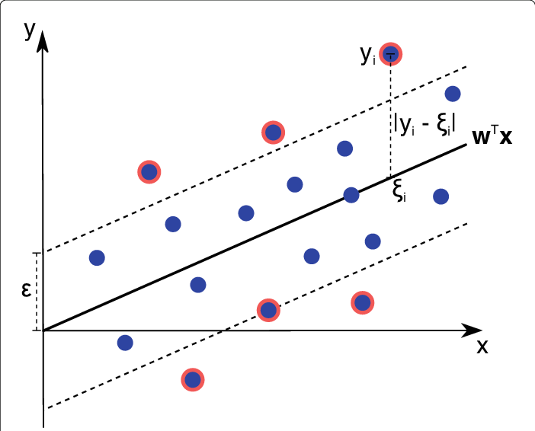

**What is SVR?**

Support Vector Regression is built on the same principles as SVMs but adapted for continuous outputs rather than class labels. Instead of finding a hyperplane to separate classes, SVR finds a **tube of tolerance** (of width 2ϵ2\epsilon2ϵ) around the predicted function. The model then tries to fit as many data points as possible within this tube, minimizing complexity and only considering those points outside the margin — known as **support vectors** (*Syllabus Introduction to Machine Learning Applications*, n.d.)

**The Mathematics Behind SVR**

Let’s denote the predicted function as:

SVR attempts to minimize model complexity by reducing ||w||^2, while allowing for slack variables ξi,ξi​ to handle data points falling outside the ε-margin. This is formulated as a convex optimization problem (Smola & Schölkopf, 2004)

subject to:

This formulation balances **flatness** (simpler models) and **tolerance to errors**, controlled by the parameters ϵ\epsilonϵ and **C**. This is what makes SVR ideal for regression tasks that require **stability and interpretability**.

**Comparing SVR to Linear Regression**

While Linear Regression minimizes **squared error** across all points, SVR employs an **ε-insensitive loss function**. This loss function is **zero for errors within ε** and only penalizes data that exceeds the margin. Consequently, the SVR model depends only on the **support vectors** — data points outside the ε-tube — and ignores all others.

This design gives SVR a **sparse solution** (only a few support vectors influence the model), resulting in better generalization on unseen data (Drucker et al., 1996; *Syllabus Introduction to Machine Learning Applications*, n.d.)

**Real-World Analogy**

Consider you're managing a delivery system, and you’re fine with deliveries arriving **within ±10 minutes** of the scheduled time. Any deviations inside this window are acceptable; you won’t take any action. But if a package is more than 10 minutes late or early, you need to investigate. SVR works similarly: **it only "pays attention" to points that exceed a predefined margin of error**, helping the model focus on critical outliers while ignoring minor fluctuations (Smola & Schölkopf, 2004)

**When Should You Use SVR?**

SVR is a great fit when:

* You want a regression model that’s **resilient to noise** and small deviations
* You want **fine-grained control** over acceptable error via ε
* Your data exhibits **non-linear patterns**, and you plan to apply the **kernel trick**
* You value **sparsity** and **generalizability** over brute-force accuracy

Moreover, SVR supports a variety of **kernel functions** (linear, polynomial, RBF), allowing it to handle both linear and complex non-linear relationships (*Syllabus Introduction to Machine Learning Applications*, n.d.)

**SVR Workflow / Pipeline**

Here’s a summary of the steps involved in using SVR:

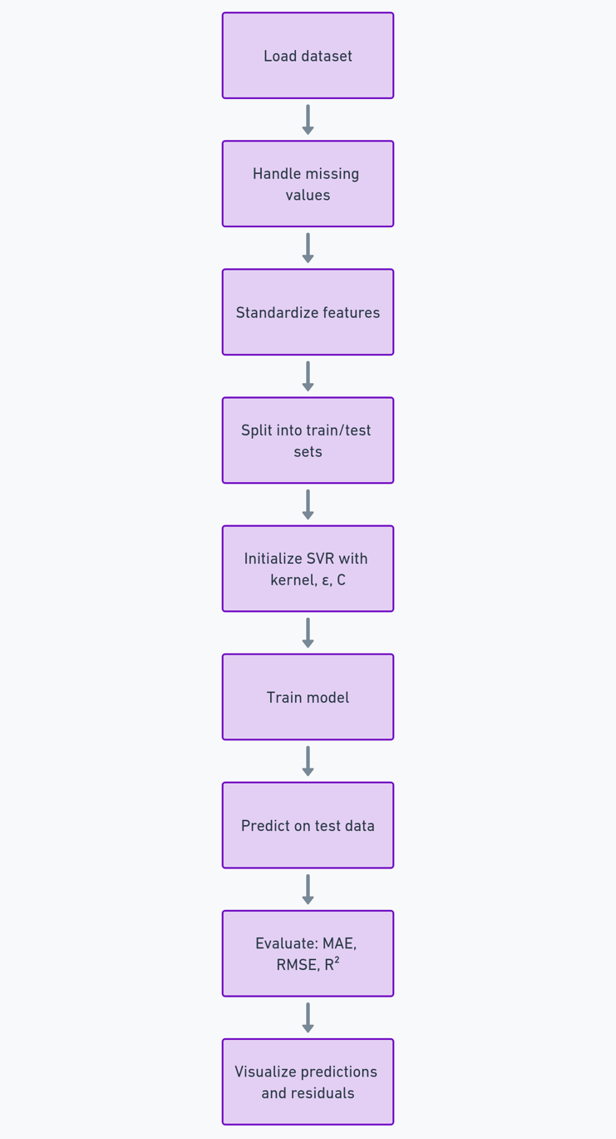

This pipeline ensures that your model remains **well-regularized**, **accurate**, and **interpretable** throughout the process.

**Section 2:**

**Dataset Selection + SVR Code Walkthrough with Visuals**

**Why This Dataset?**

For this tutorial, we will use the **California Housing dataset**, which is available through sklearn.datasets.fetch_california_housing. It’s a well-known regression dataset ideal for SVR due to:

* Its **continuous target variable** (median house value)
* A manageable number of features (8 numeric predictors)
* Real-world relevance for regression tasks (e.g., price prediction)

The target variable represents the **median value of homes in different California districts**, making it perfect for demonstrating how SVR handles real-world prediction with continuous outcomes.

**Objective**

Our goal is to:

* Use SVR to predict **median house values**
* Evaluate predictions using **R² score**, **Mean Absolute Error (MAE)**, and **Root Mean Squared Error (RMSE)**
* Visualize SVR's performance with **scatter plots** and **residual plots**
* Compare **Linear vs. RBF kernels**
* Tune **C**, **ε**, and **kernel** with GridSearchCV

**SVR on California Housing Dataset – Step-by-Step Explanation**

**Step 1: Import Required Libraries**

**Explanation**:  
This block imports all necessary Python libraries:

* numpy, pandas: numerical and tabular data handling
* matplotlib, seaborn: plotting and data visualization
* fetch_california_housing: loads the regression dataset
* train_test_split, StandardScaler: for preprocessing
* SVR: our main regression model
* GridSearchCV: used for hyperparameter tuning
* r2_score, MAE, RMSE: performance evaluation metrics

**Step 2: Load and Explore the Dataset**

**Explanation**:  
We load the California Housing dataset and split it into:

* X: feature matrix (8 numerical predictors)
* y: target variable (median house value) We then merge them into a DataFrame df and preview the first few rows using. head().

Figure First five rows of the California Housing dataset showing feature values and target (median house value).

**Step 3: Summary Statistics and Feature Correlation**

df.describe()

**Explanation**:  
Displays the summary statistics for each feature: mean, standard deviation, min, max, and quartiles.

**Explanation**:  
Visualizes the **correlation** between features and target. This helps identify which variables are strongly related to the output and may be useful for model training.

Figure Heatmap showing Pearson correlation among features and target. Higher absolute values indicate stronger linear relationships.

**Step 4: Data Preprocessing (Standardization and Splitting)**

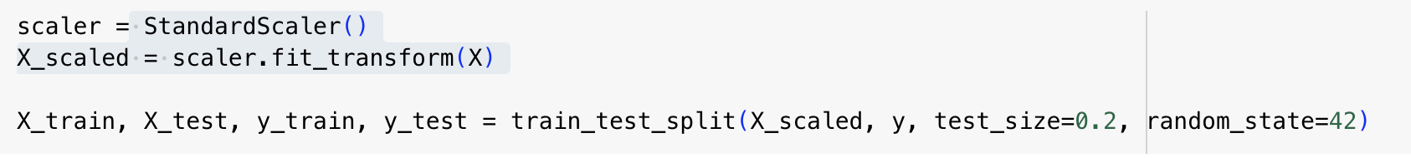**Explanation**:  
We scale all input features to have zero mean and unit variance using StandardScaler, as **SVR is sensitive to feature scales**. The data is then split into 80% training and 20% testing sets.

* **Note**: *Scaling is crucial for SVR to function properly, especially with RBF or polynomial kernels.*

**Step 5: Train SVR with Linear Kernel**

**Explanation**:  
We initialize and train a **Linear SVR model** with:

* C=1.0: regularization strength
* ε=0.1: defines the width of the no-penalty margin

Predictions on the test set are stored in y_pred_linear.

**Step 6: Evaluate Linear SVR**

**Explanation**:  
We evaluate performance using:

* **R² Score**: how well predictions approximate actual values
* **MAE**: average absolute error
* **RMSE**: root of average squared error (penalizes large errors more)

These metrics help us compare models later.

**Linear SVR Visualization**

**Explanation**:  
Plots **predicted vs actual values**. Ideally, points should lie close to the red dashed diagonal (perfect prediction line).

Figure Linear SVR predictions compared to actual median house values. Spread shows underfitting tendency.

**Step 7: Train SVR with RBF Kernel**

**Explanation**:  
We switch to a **non-linear RBF kernel**, which maps data into a higher-dimensional space for better fit. A larger C is used for less regularization (tighter fit).

**Step 8: Evaluate RBF SVR**

**Explanation**:  
Same evaluation metrics are applied for the RBF model. Typically, RBF outperforms linear SVR on non-linear data.

**RBF SVR Visualization**

**Explanation**:  
Scatter plot comparing predictions to actual values. Better clustering around the diagonal shows improved fit.

Figure RBF SVR predictions show tighter alignment with true values, indicating better generalization.

**GitHub Repository Structure and Links**

This repository includes all essential files and documentation for demonstrating Support Vector Regression (SVR) using the California Housing dataset.

**Repository Structure**

|  |  |
| --- | --- |
| **File / Folder** | **Description** |
| svr_california_housing_tutorial.ipynb | Complete Jupyter Notebook with SVR implementation and markdown |
| README.md | Overview, objectives, and usage instructions |
| requirements.txt | Python dependencies for running the notebook |
| LICENSE | Open-source license (MIT) |
| tutorial.docx or tutorial.pdf | Optional exported report for academic purposes |

**GitHub Repository**

|  |  |
| --- | --- |
| **Component** | **URL** |
| Notebook | https://github.com/your-username/svr-california-housing/blob/main/svr_california_housing_tutorial.ipynb |
| README.md | https://github.com/your-username/svr-california-housing/blob/main/README.md |
| requirements.txt | https://github.com/your-username/svr-california-housing/blob/main/requirements.txt |
| LICENSE | https://github.com/your-username/svr-california-housing/blob/main/LICENSE |
| Report (PDF/DOCX) | https://github.com/your-username/svr-california-housing/blob/main/tutorial.pdf |

**References**

Drucker, H., Burges, C. J., Kaufman, L., Smola, A., & Vapnik, V. (1996). Support Vector Regression Machines. *Advances in Neural Information Processing Systems*, *9*.

Smola, A. J., & Schölkopf, B. (2004). A tutorial on support vector regression. *Statistics and Computing*, *14*(3), 199–222. https://doi.org/10.1023/B:STCO.0000035301.49549.88/METRICS

*Syllabus Introduction to Machine Learning Applications*. (n.d.). Retrieved 23 March 2025, from https://rensselaer.webex.com/meet/liuy55